Referral Application | 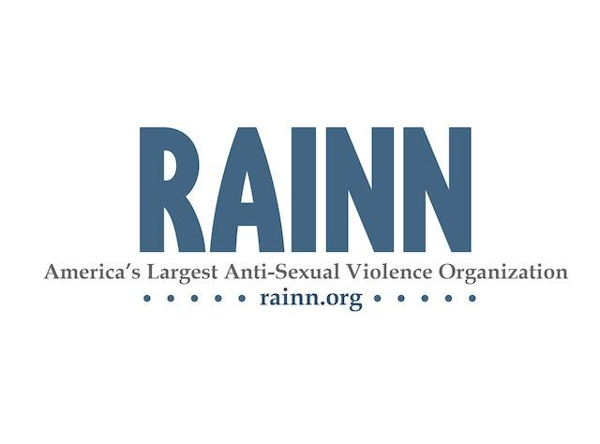

Note: Information marked with an * will be displayed in your listing at www.centers.rainn.org

Organization’s Contact Information
*Organization Name
Mailing Address
*City, State, Zip Code
*Counties the organization serves
*Business Phone Number
*Organization’s Website
CEO/Executive Director Name
CEO/Executive Director Email Address

Primary Contact’s Information
Primary Contact Name
Primary Contact Title
Primary Contact Phone Number
Primary Contact Email Address

Services Provided
*Hotline Phone Number
*Toll-Free Hotline Number
If different from Hotline Number above.
Does the hotline operate 24 hours a day, everyday?
If yes, is the hotline answered by your staff/volunteers
24 hours or is it routed to another organization after hours?

If not 24/7, what hours does your hotline operate?
Who provides the direct services at your organization? (paid staff, volunteers, etc)

*Please describe your services below.

*Please describe any eligibility requirements for services below.

*Are the organizations staff/volunteers specially trained to provide services to any of the following populations?

☐ | Disabled | ☐ | Elderly | ☐ | Family of victim/survivor | ☐ | Adults abused/assaulted as children
☐ | LGBTQ | ☐ | Minors | ☐ | Men | ☐ | Teens
☐ | Veterans | ☐ | Homeless | ☐ | Adult Incest Survivors | ☐ | Suicidal Callers
☐ | 2-1-1 | ☐ | Adults experiencing domestic violence | ☐ | Deaf and Hard Hearing (TTY) | ☐ | Non-English Speakers (not including Spanish)
☐ | Spanish Speakers | ☐ | Other:

*What additional services does your organization provide?

☐ | Group Counseling | ☐ | Individual Counseling | ☐ | Community Education | ☐ | Legal/Criminal Advocacy
☐ | Emergency Shelter | ☐ | Case Management | ☐ | Professional Education | ☐ | Crime Victim Assistance
☐ | Other:

Staff and Volunteer Training
Does the organization train staff and volunteer counselors/advocates to meet the diverse needs of sexual assault survivors?
If yes, how many hours are required/provided?
Did a mental health professional design the training?
Are criminal background checks conducted on all volunteer and staff counselors/advocates?
Does the organization provide chat or web-based services?
If yes, please describe:
Does the organization have a written policy stating compliance with your state’s mandatory reporting laws?
How does the organization provide long-term services to male survivors?

Collaboration with the State Coalition
Is the organization a member of your state coalition?
If no, please explain:
Is the organization in compliance with state, county, and local statutes and regulations governing your operations?

Confidentiality Policy

Referral organizations will respect client’s rights to confidentiality and will adhere to a confidentiality policy that includes the following items:
- A client will never be pressured into revealing their identity.
- Victim records will not be released without the consent of the victim, except when an organization is obligated by law.
- Reports of the assault will be made to police or other agencies only with the client’s consent, except when an organization is obligated by law to report the attack.

I affirm that, as a referral organization, my organization will adhere to the confidentiality policy above.

Executive Director/CEO’s Initials: __________________ Date: ______________

Non-Discrimination Policy

Referral organizations shall not discriminate against any individual for reasons of race, color, creed, religion, sexual orientation, gender identity, national origin, sex, age, language, disability or political party identification. Accordingly, equal access to employment opportunities and services is extended to all persons.

I affirm that, as a referral organization, my organization will adhere to the non-discrimination policy above.

Executive Director/CEO’s Initials: __________________ Date: ______________

By signing below and submitting this application affirm that all answers stated in this application are true; that your organization provides free, or low cost, services to all survivors of sexual assault without discrimination on any basis; and that you will abide by the confidentiality policy.

Name of CEO/Executive Director (please print): ________________________________________________________

Signature of CEO/Executive Director: _______________________________________ Date: ______________

Please return completed application to the RAINN NSAH Affiliate Coordinator:
Fax: 202.544.3556 Mail: RAINN 1220 L St NW, Suite 505, Washington, DC 20005 Email: ValerieT@rainn.org
Questions? Call the NSAH Director at: 202-751-3220

