Affiliate Application | 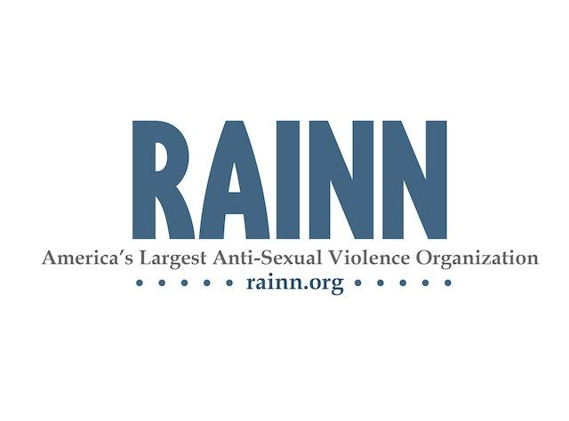

Note: Information marked with an * will be used on the organizations page at www.centers.rainn.org

Organization’s Contact Information
*Organization Name
Mailing Address
*City, State, Zip Code
*Counties the organization serves
*Business Phone Number
*Organization’s Website
CEO/Executive Director Name
CEO/Executive Director Email Address

Primary Contact’s Information
Primary Contact Name
Primary Contact Title
Primary Contact Phone Number
Primary Contact Email Address

Hotline and Service Information
*Hotline Phone Number
Please note you must list a direct dial number not a toll-free number. This is the number the NSAH will be routed to.
*Toll-Free Hotline Number
Please note this number will be displayed on the RAINN website but we cannot route the NSAH to this number.
What percentage of hotline calls are related to sexual assault?
Does the hotline operate 24 hours a day, everyday?
If yes, is the hotline answered by your staff/volunteers
24 hours or is it routed to another organization after hours?
How does the organization train their staff and volunteer counselors/advocates to meet the diverse needs of sexual assault survivors?
If yes, how many hours are required/provided?
Did a mental health professional design the training?
Are criminal background checks conducted on all volunteer and staff counselors/advocates?
Does the organization provide chat or web-based services?
If yes, please describe:
Does the organization have a written policy stating compliance with the states mandatory reporting laws?
How does the organization provide long-term services to male survivors?

Collaboration with the State Coalition
Is the organization a member of the state coalition?
If no, please explain:
Is the organization in compliance with state, county, and local statutes and regulations governing your operations?

Additional Services Provided

*Please describe your services below in 1-2 sentences.

*Please describe any eligibility requirements for services below in 1-2 sentences.

*Are the organizations staff/volunteers trained to provide services to any of the following populations?
☐ | Disabled | ☐ | Elderly | ☐ | Family of victim/survivor | ☐ | Adults abused/assaulted as children
☐ | LGBTQ | ☐ | Minors | ☐ | Men | ☐ | Teens
☐ | Veterans | ☐ | Homeless | ☐ | Adult Incest Survivors | ☐ | Suicidal Callers
☐ | 2-1-1 | ☐ | Adults experiencing domestic violence | ☐ | Deaf and Hard Hearing (TTY) | ☐ | Non-English Speakers (not including Spanish)
☐ | Spanish Speakers | ☐ | Other:

*What additional services does your organization provide?
☐ | Group Counseling | ☐ | Individual Counseling | ☐ | Community Education | ☐ | Legal/Criminal Advocacy
☐ | Emergency Shelter | ☐ | Case Management | ☐ | Professional Education | ☐ | Crime Victim Assistance
☐ | Other:

We are excited about your interest in affiliating with RAINN. Below, please share with us why you are interested in partnering with RAINN and how RAINN can assist the organization's efforts to support survivors of sexual violence:

RAINN Confidentiality Policy

Obligations of RAINN

RAINN commits to making every effort to ensure the anonymity of every caller to its hotline. When a
call is placed to RAINN’s 800 number, only the area code and exchange of the caller will be captured.
The caller’s phone number will not be captured.

It is RAINN’s expectation that, because we do not retain the phone numbers of callers, our records will
be of little interest to court proceedings. Nevertheless, should our call records be subpoenaed,
RAINN commits to using legal means at our disposal to fight such a subpoena.

Obligations of participating rape crisis centers

RAINN expects that participating centers will respect callers’ rights to confidentiality and will adhere to
a confidentiality policy that includes the following items.
- A caller will never be pressured into revealing their identity.
- Victim records will not be released without the consent of the victim, except when a center is obligated by law.
- Reports of the assault will be made to police or other agencies only with the client’s consent, except when a center is obligated by law to report the attack.

I affirm that, as an affiliate my organization will adhere to RAINN’s confidentiality policy.

Executive Director/CEO’s Initials: __________________ Date: ______________

RAINN Non-Discrimination Policy

RAINN and its affiliated centers shall not discriminate against any individual for reasons of race, color, creed, religion, sexual orientation, gender identity, national origin, sex, age, language, disability or political party identification. Accordingly, equal access to employment opportunities and services is extended to all persons.

I affirm that, as an affiliate my organization will adhere to RAINN’s non-discrimination policy.

Executive Director/CEO’s Initials: __________________ Date: ______________

Affiliate Terms of Service

Below is an outline of what services RAINN offers affiliate organizations and what RAINN requires their affiliates provide to survivors of sexual violence.

RAINN will Provide to All Affiliates:
- Promotion of the affiliate’s services: RAINN offers the opportunity for affiliates to list their services for victims and survivors and volunteer opportunities on the RAINN website (rainn.org). In addition, RAINN partners with media outlets to promote the National Sexual Assault Hotline (NSAH).
- Access to Promotional Materials: RAINN offers web based promotional materials as needed. Affiliates can also promote the NSAH in their local promotion. Promoting this number ensures an affiliates ability to target survivors in their region.
- Hotline Reports: RAINN provides affiliates with bi-annual reports detailing the number of calls routed to the organization from the NSAH.
- Access to support: The NSAH Affiliate Coordinator is available to assist affiliates with concerns and questions related to local and national issues.
- Access to online trainings: RAINN provides access to online trainings for staff and volunteers.
- Quality assurance of the NSAH: RAINN staff will follow-up with all concerns expressed by callers and centers in a timely manner.

Affiliates will:
- Provide services via a 24-hour hotline: Affiliates will ensure their hotline number is answered 24-hours a day, 7-days a week, 365 days a year by trained paid or non-paid staff. Affiliates agree to provide free, confidential hotline services to all callers.
- Provide services to survivors without discrimination: Affiliates agree to adhere to RAINN’s discrimination and confidentiality policies.
- Notify RAINN of changes to services: Affiliates agree to provide RAINN with a 30-day notice if they anticipate any change to their hotline services.
By signing below and submitting this application to join RAINN’s network, you agree to adhere to the Affiliate Terms of Service. You also affirm that all answers stated in this application are true, that your organization provides free services to all survivors of sexual assault without discrimination on any basis, and that you will abide by RAINN’s confidentiality policy.

Name of CEO/Executive Director (please print): ________________________________________________________

Signature of CEO/Executive Director: _______________________________________ Date: ______________

Please return completed application to the RAINN NSAH Affiliate Coordinator:
Fax: 202.544.3556 Mail: RAINN 1220 L St NW, Suite 505, Washington, DC 20005 Email: ValerieT@rainn.org
Questions? Call the NSAH Affiliate Coordinator at: 202-751-3220

